Lab Exercise 9- Enable WORM Governance Mode, Test Delete Protection, Restore Object, and Remove Bucket

Objective
- Install MinIO & mc
- Create bucket with object-lock
- Enable versioning before upload
- Configure Governance retention
- Upload object & test delete protection
- Delete marker behavior
- Bypass delete marker
- Restore file version successfully
- Remove bucket at the end

STEP 1 — Install MinIO
wget https://dl.min.io/server/minio/release/linux-amd64/minio
chmod +x minio
sudo mv minio /usr/local/bin/

Create storage location:
sudo mkdir -p /mnt/data
sudo chown $USER:$USER /mnt/data

STEP 2 — Start MinIO Server
export MINIO_ROOT_USER="minioadmin"
export MINIO_ROOT_PASSWORD="Minio@12345"

minio server /mnt/data --console-address ":9001"

Access UI:
http://127.0.0.1:9001

STEP 3 — Install mc
Open a new terminal:
wget https://dl.min.io/client/mc/release/linux-amd64/mc
chmod +x mc
sudo mv mc /usr/local/bin/
Configure alias:
mc alias set local http://127.0.0.1:9000 minioadmin Minio@12345

STEP 4 — Create Bucket WITH WORM Support
mc mb --with-lock local/wormbucket

STEP 5 — Enable Versioning BEFORE Upload
mc version enable local/wormbucket

mc version info local/wormbucket

Expected:
Versioning: Enabled

STEP 6 — Apply Governance retention BEFORE upload
mc retention set governance 1d local/wormbucket --default

Verify:
mc retention info local/wormbucket

Expected output:
Mode: GOVERNANCE
Validity: 1d (default bucket retention)

STEP 7 — Upload Object
echo "This is WORM protected object" > worm.txt

mc cp worm.txt local/wormbucket

List versions:
mc ls –versions local/wormbucket

Expected:
worm.txt#<PUT_VERSION_ID> v1 PUT

STEP 8 — Test Delete Protection
mc rm local/wormbucket/worm.txt
Expected:
Created delete marker `worm.txt`
List versions again:
mc ls --versions local/wormbucket

Expected:
[DELETED] worm.txt#<DEL_VERSION_ID>
worm.txt#<PUT_VERSION_ID>

STEP 9 — Remove Delete Marker using Governance Bypass
mc rm –bypass local/wormbucket/worm.txt –version-id <DEL_VERSION_ID>

Confirm:
mc ls --versions local/wormbucket
Expected:
worm.txt#<PUT_VERSION_ID>

STEP 11 — Attempt delete real version (should fail)
mc rm local/wormbucket/worm.txt --version-id <PUT_VERSION_ID>
Expected:
mc: <ERROR> Object is WORM protected and cannot be deleted.

STEP 12 — Bypass delete real version
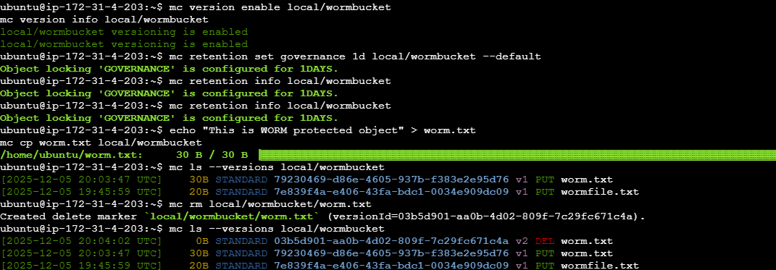
mc rm --bypass local/wormbucket/worm.txt --version-id <PUT_VERSION_ID>

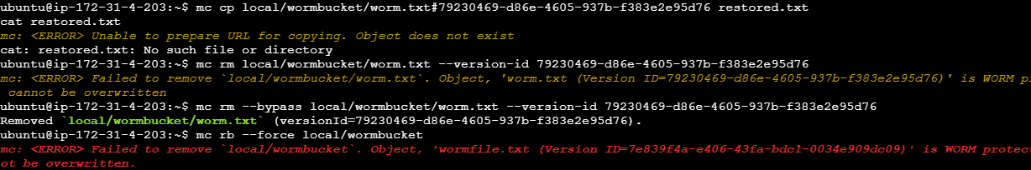
Expected:
Removed `worm.txt`

